**Swash Zone**

The swash zone is the section of wave action on the beach characterized by the layer of water that washes ashore after a wave breaks.

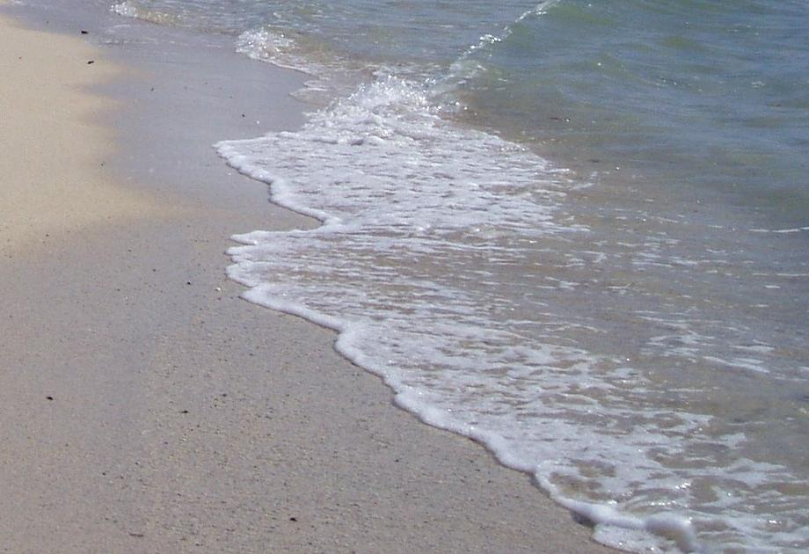

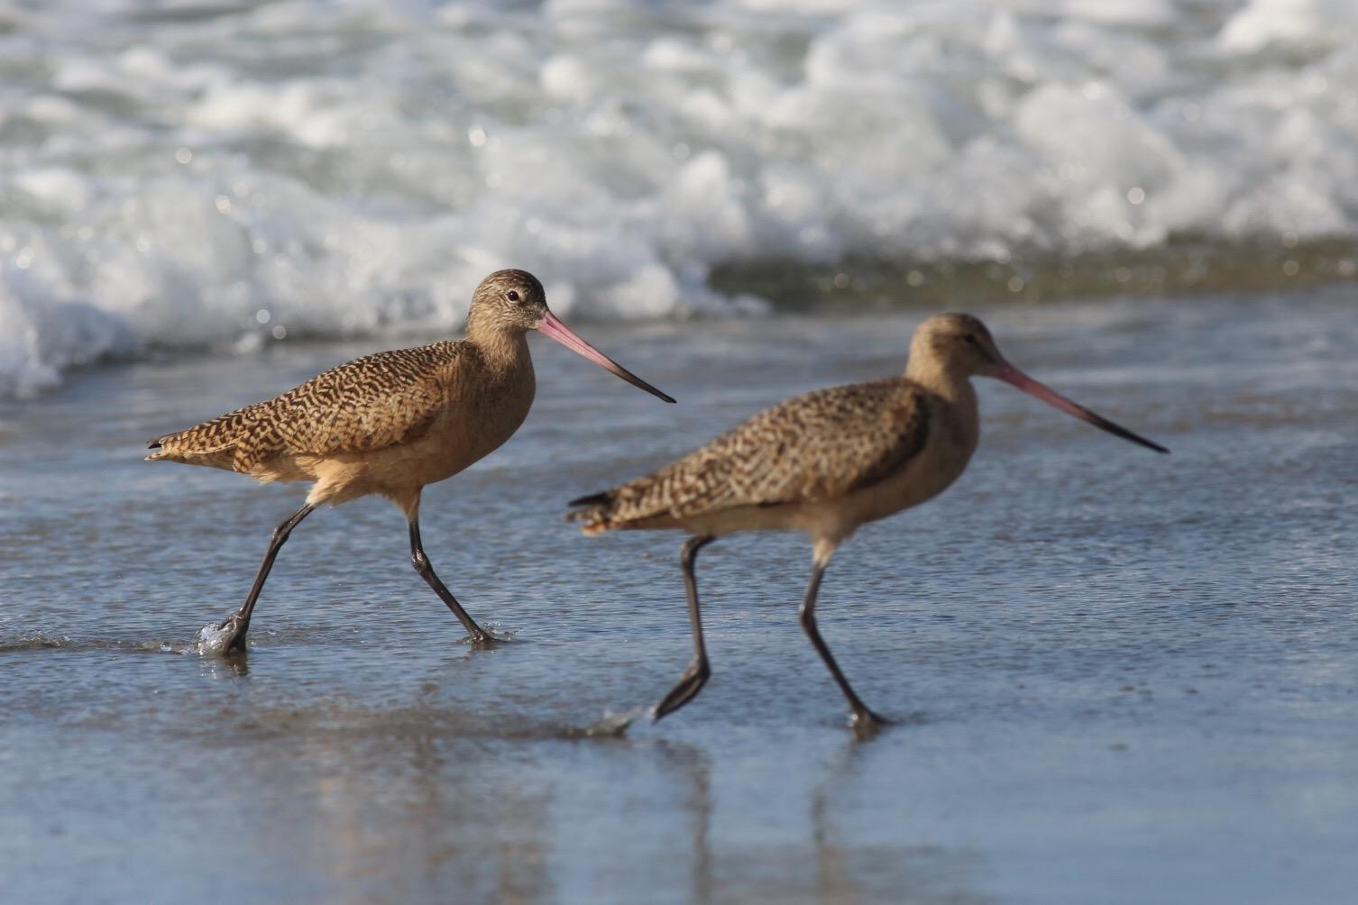

**Prey found in Intertidal Zone**

* **Tiny snails**
* **Worms**
* **Invertarates**
* **Larva**
* **Clams**
* **Shrimp**

**Worms Clams**

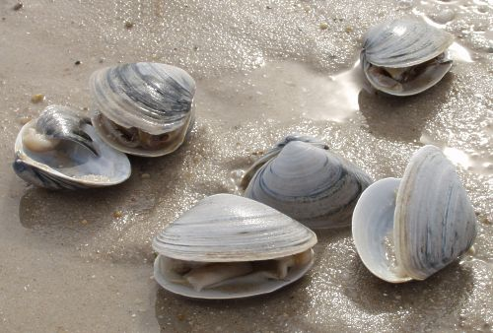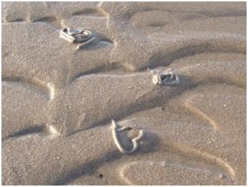

**Organisms Found In Wrack Line**

* Seaweed
* Beach grass
* Kelp flies
* Beach hoppers
* Roly polies
* Rove Beatle
* Insects

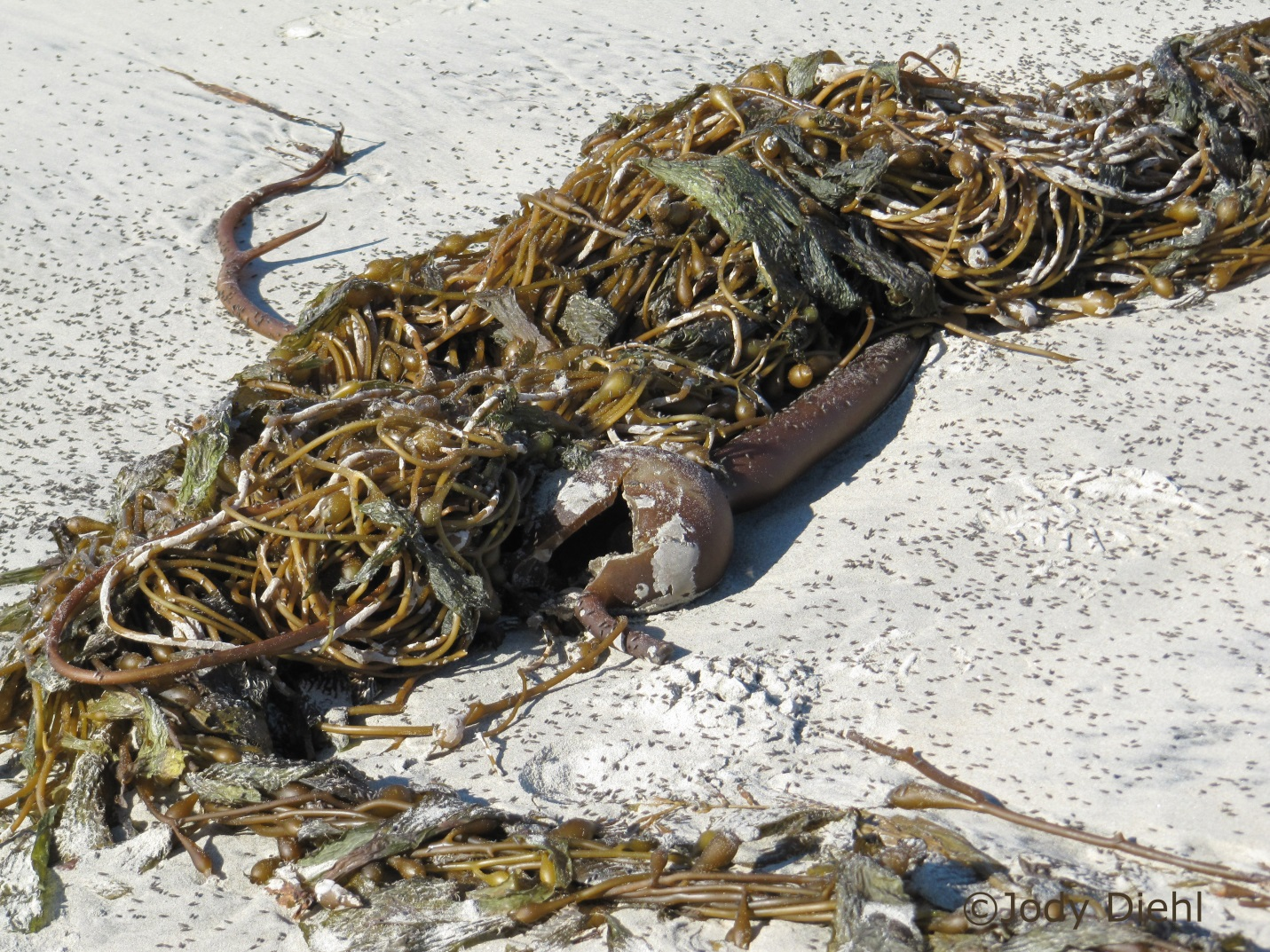

**Intertidal Zone**

The intertidal zone is the area between the high tide point and the low tide mark

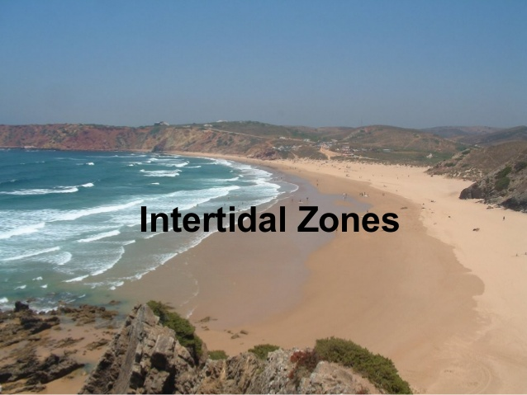

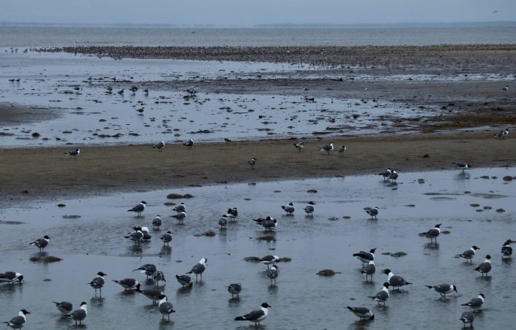

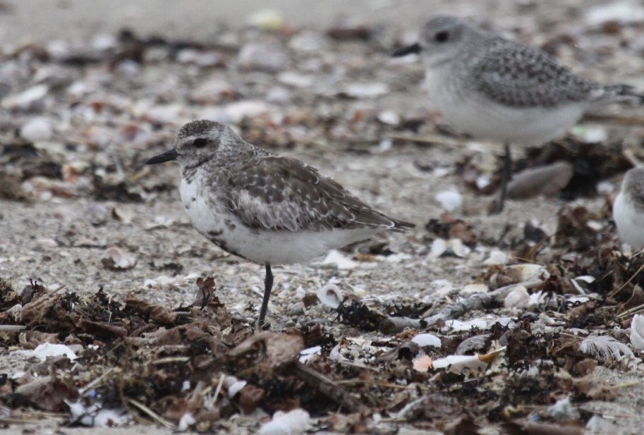

The wrack line is the line of debris left on the beach from high tide. The wrack is made up of drift wood, seaweed, shells and litter that washes ashore

**Wrack Deposit**

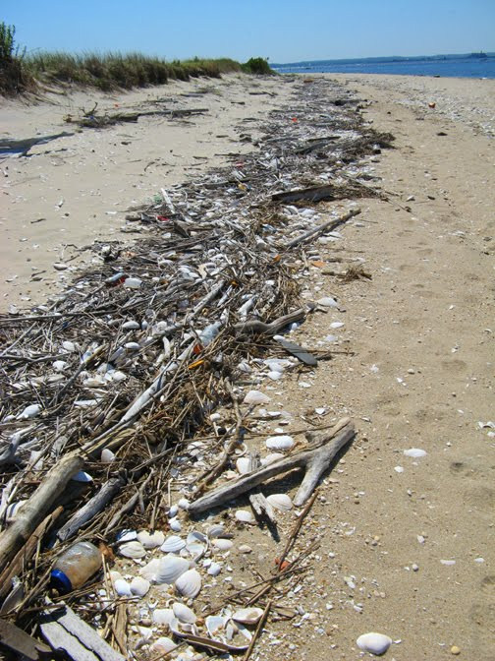

**Beach Zones**

**Parker River Wildlife Refuge**

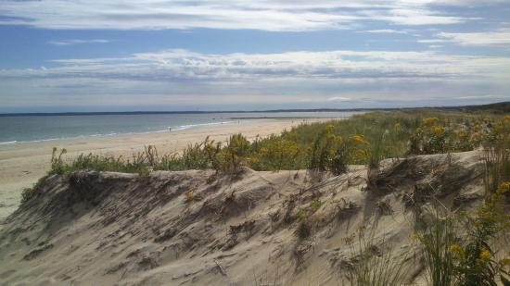

**Swash, Intertidal, and Wrack Line**