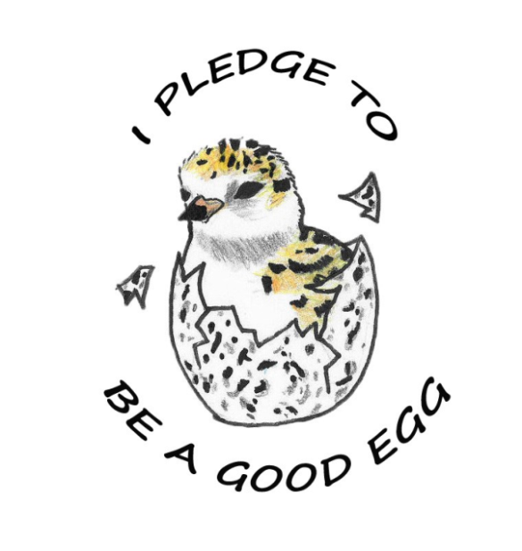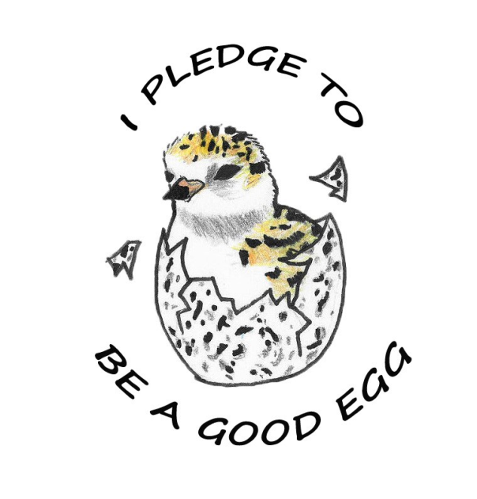+

* **Leave dogs at home**
* **Respect signs and keep away from plovers and other shorebirds**
* **Pack out trash from the beach**
* **Leave shells and other natural debris as hiding and feeding areas for birds**

**Parker River**

**National Wildlife Refuge**

* **Leave dogs at home**
* **Respect signs and keep away from plovers and other shorebirds**
* **Pack out trash from the beach**
* **Leave shells and other natural debris as hiding and feeding areas for birds**

**Parker River**

**National Wildlife Refuge**

* **Leave dogs at home**
* **Respect signs and keep away from plovers and other shorebirds**
* **Pack out trash from the beach**
* **Leave shells and other natural debris as hiding and feeding areas for birds**

**Parker River**

**National Wildlife Refuge**

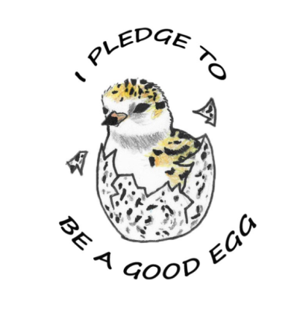

* **Leave dogs at home**
* **Respect signs and keep away from plovers and other shorebirds**
* **Pack out trash from the beach**
* **Leave shells and other natural debris as hiding and feeding areas for birds**

**Parker River**

**National Wildlife Refuge**

* **Leave dogs at home**
* **Respect signs and keep away from plovers and other shorebirds**
* **Pack out trash from the beach**
* **Leave shells and other natural debris as hiding and feeding areas for birds**

**Parker River**

**National Wildlife Refuge**

* **Leave dogs at home**
* **Respect signs and keep away from plovers and other shorebirds**
* **Pack out trash from the beach**
* **Leave shells and other natural debris as hiding and feeding areas for birds**

**Parker River**

**National Wildlife Refuge**

* **Leave dogs at home**
* **Respect signs and keep away from plovers and other shorebirds**
* **Pack out trash from the beach**
* **Leave shells and other natural debris as hiding and feeding areas for birds**

**Parker River**

**National Wildlife Refuge**