Shorebirds

Parker River Wildlife Refuge

Photobook and Guide

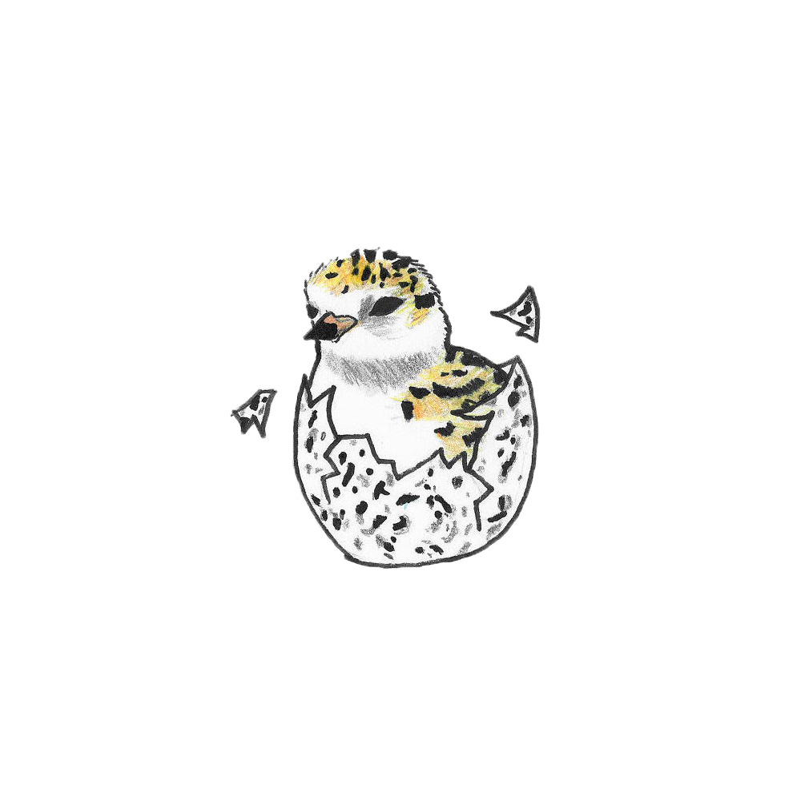

Semipalmated Sandpiper

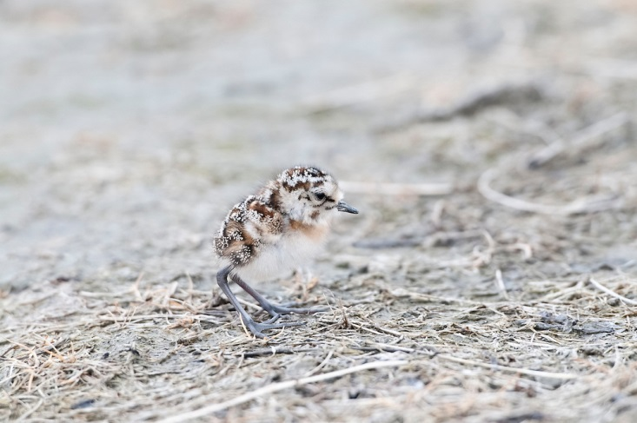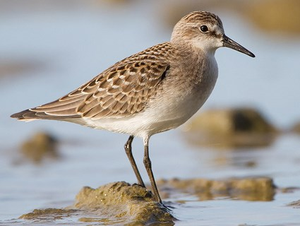

Length: 13-15 cm

What they eat: Worms, mollusks and insects

Where they feed: Mudflats and shorelines at low tide

Baby Semipalmated Sandpiper

Semipalmated Sandpiper Feeding

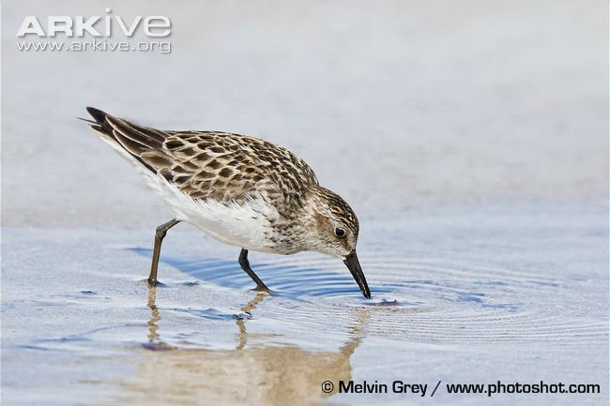

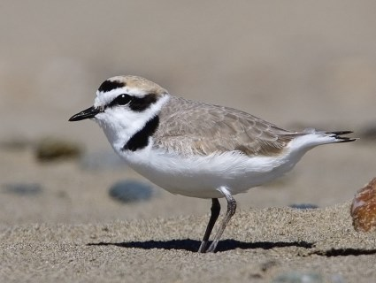

Semipalmated Plover

Length: 17-19 cm

What they eat: Insects and worms

Where they feed: Shoreline

Semipalmated Plover Feeding

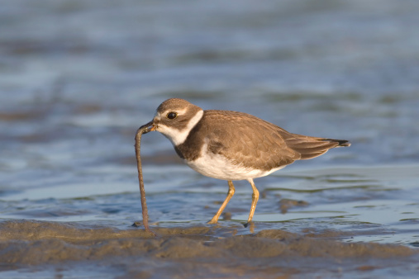

Semipalmated Plover Baby

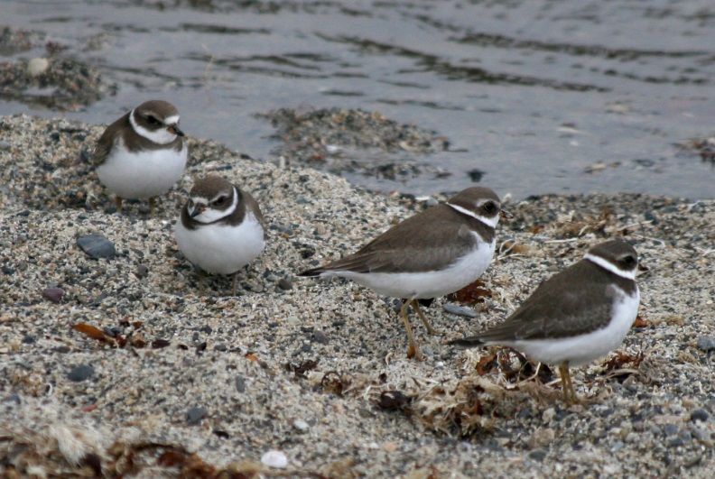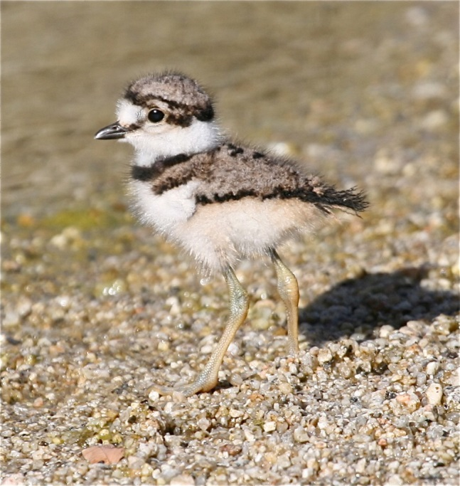

Semipalmated Plover Group

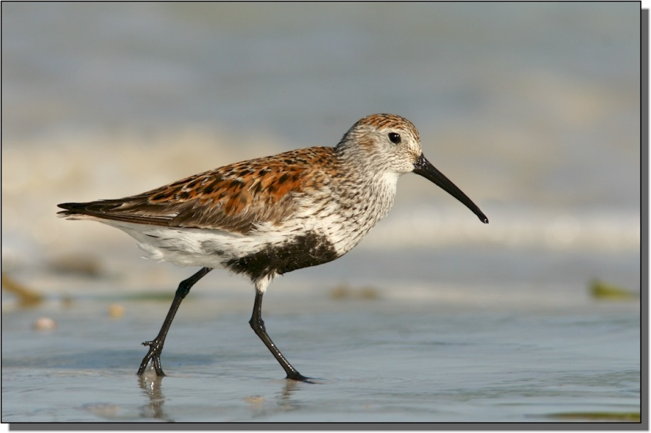

Length: 16-20 cm

What they eat: Insects

Where they feed: Mudflats

Dunlin

Dunlins Roosting

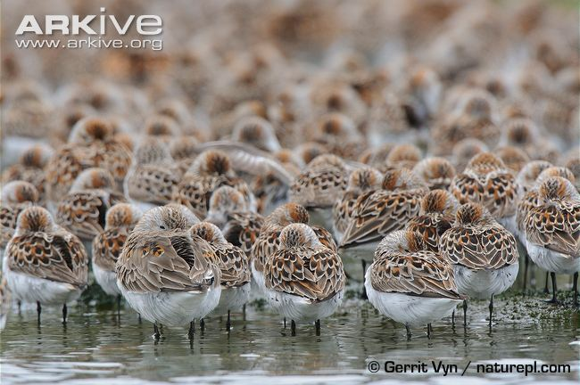

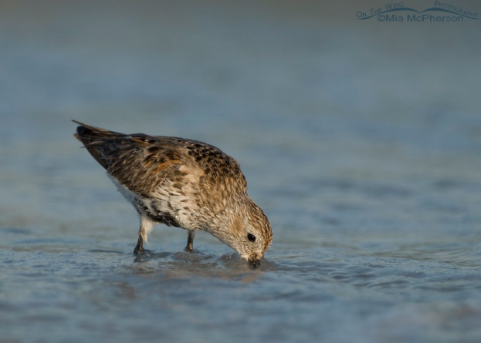

Roosting: Birds resting or sleeping

Dunlin Feeding

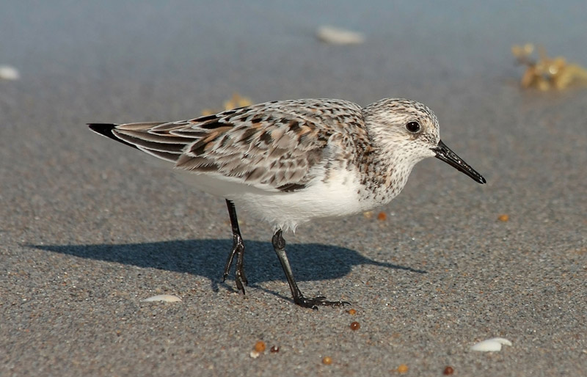

Sanderling Baby

Sanderling

Length: 18-20 cm

What they eat: flying insects or plant material

Where they feed: follow receding

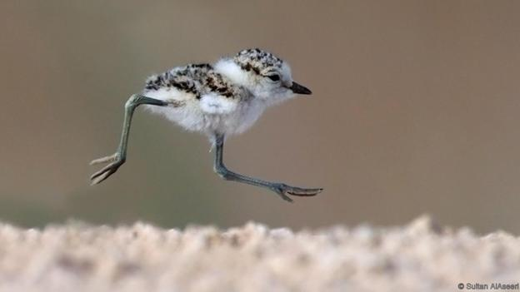

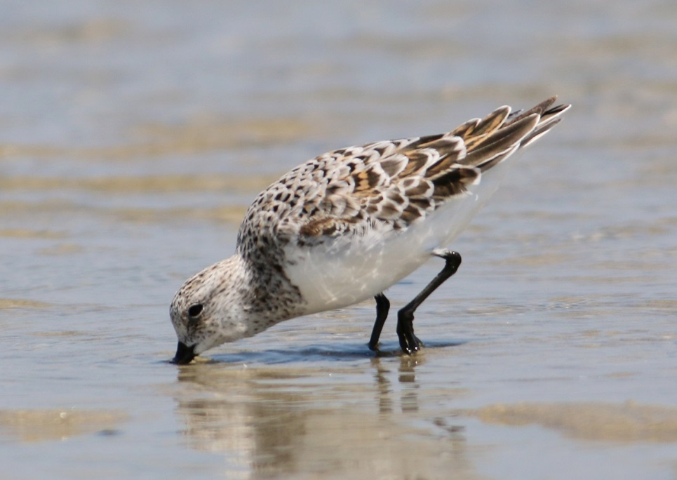

Sanderling Feeding

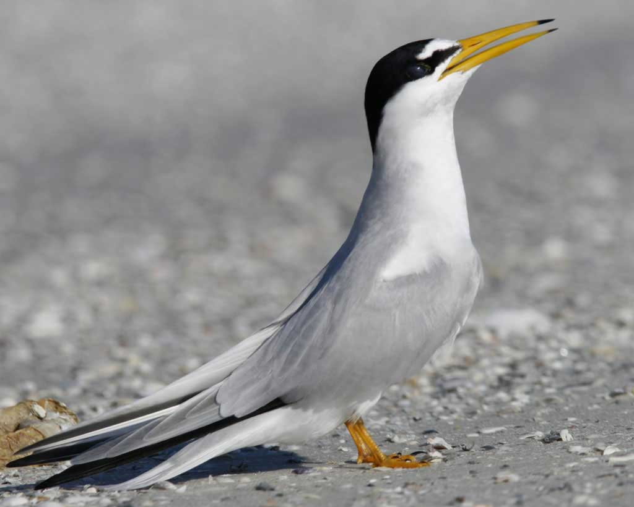

Length: 21-23 cm

What they eat: small fish and some invertebrates

How they feed: Plunges into the water

Least Tern

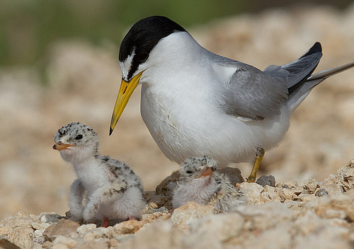

Least Tern Baby

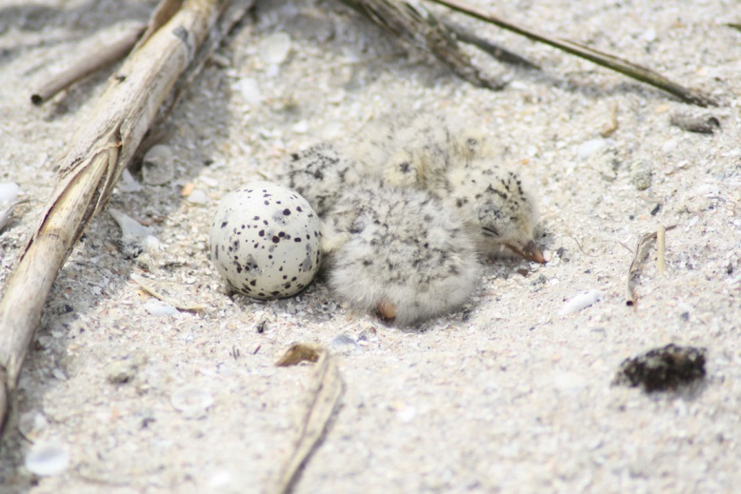

Least Tern Nest

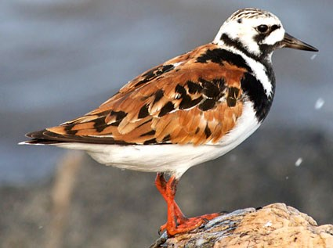

Ruddy Turnstone

Length: 21-26 cm

What they eat: insects

Where they feed: uncover rocks and debris on the beach

Ruddy Turnstone Feeding

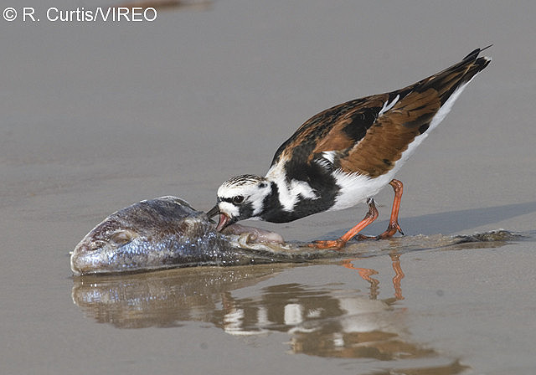

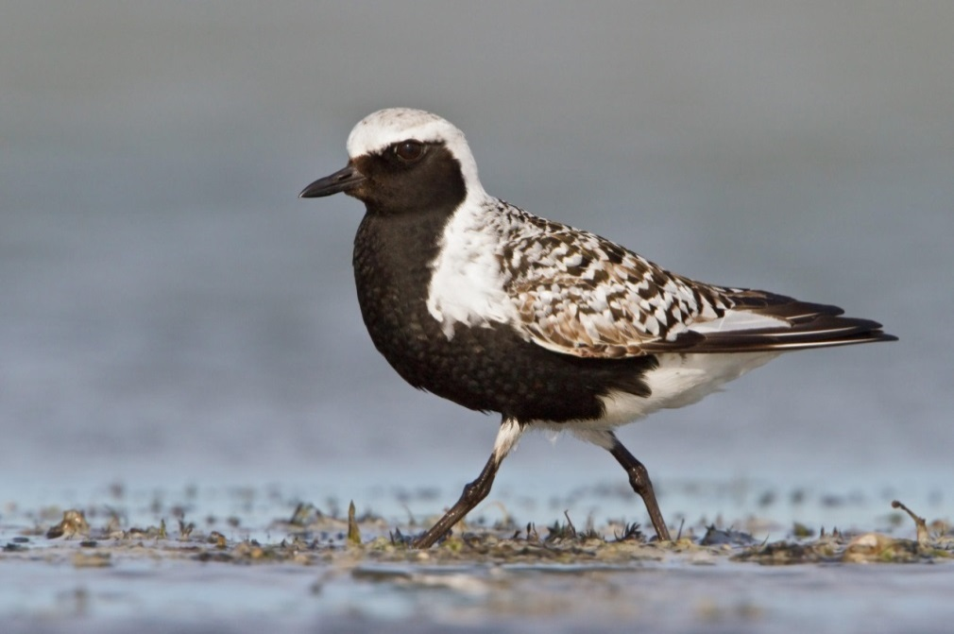

Black Bellied Plover

Length: 28-29 cm

What they eat: insects and invertebrates

How they feed: capture prey through pecks

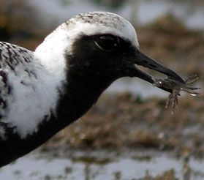

Black Bellied Plover Feeding

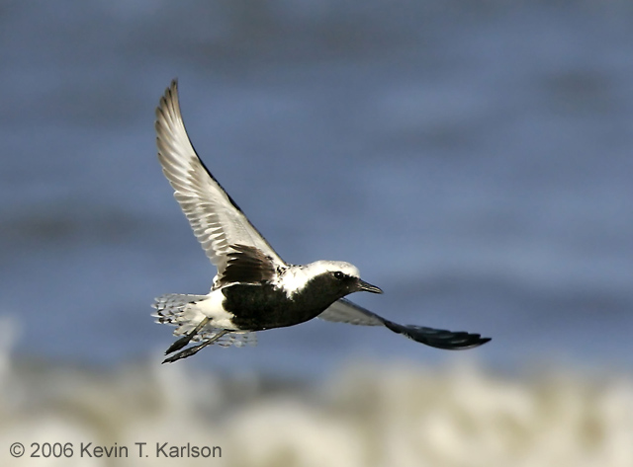

Black Bellied Plover Inflight

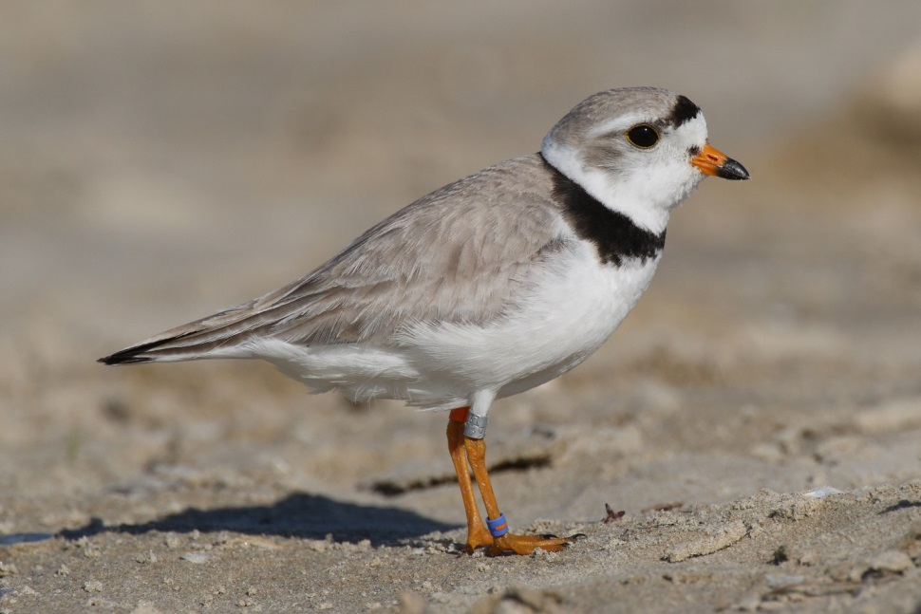

Length: 17-18 cm

What they eat: fresh water and marine invertebrates

Where they feed: 16 feet from water

Piping Plover

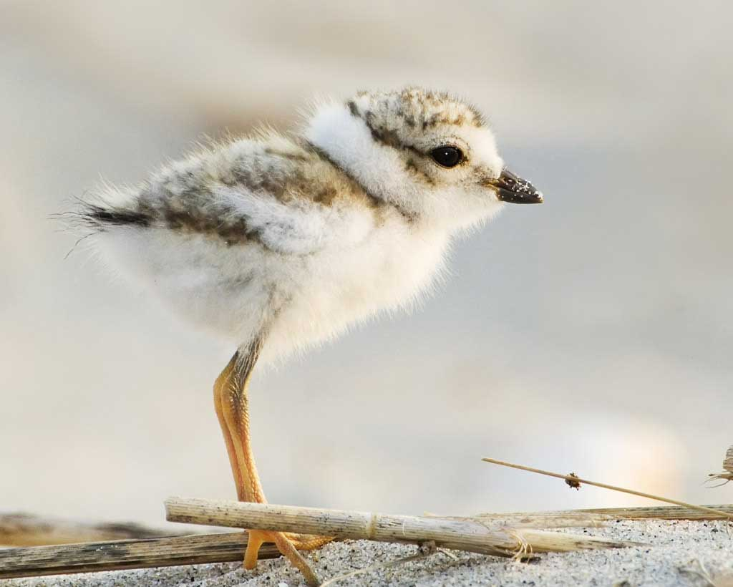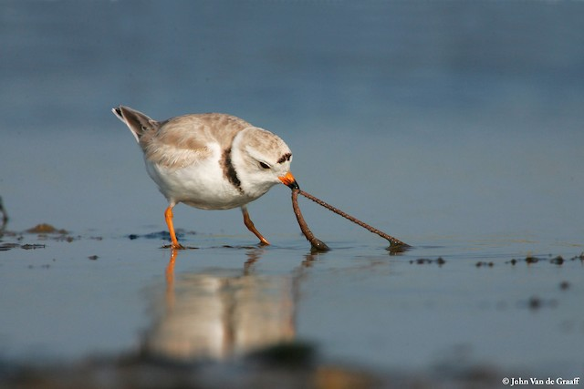

Piping Plover Baby

Piping Plover Feeding